KINGA KLOSKOWSKA

DESIGN PRINCIPLES AND CONTEXT

3D GAME LEVEL

DESIGN DOCUMENT

CM2113

***Page of Contents***

***Page 1***

Mood Board, Project Timeline……………………

***Page 2***

Project Idea, 3D Scanned Object List…………………..

***Page 3***

Project Design Prototype………………….

***Page 4***

Functional and Non-Functional Requirements……….

***Page 5***

Unity Asset Referencing, Harvard Referencing……….

***Mood board***

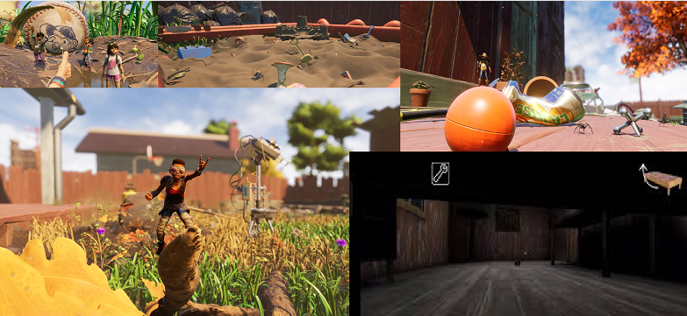

**Inspiration –** Grounded (Game), little humans, shrinking, exploration.

***Project Timeline***

**15th – 22nd of March 2023** – 3D Scanning alongside the main character (biped girl toy) and additional props for the level design.

**23rd – 31st March 2023** – Preparing the design document highlighting the previously scanned characters, expressing my ideas for the game, creating potential sketches and mood boards. Figuring out the components needed in order to run the game smoothly.

**1st – 10th April 2023** – Creating in-game environment focused on the tiny bedroom and a bed, building the foundations and room design using tools found within unity asset marketplace.

**11th – 20th April 2023** – Populating the game with the 3D scanned assets alongside some copyright free asset (bed) from the unity store. Using a bed asset because I don’t own a bed as such.

**21st – 25th April 2023** – Final game polishing, resolving final errors. Preparing a script to detail what is happening within the game, record a voiced gameplay.

**26th – 30th April** – Completing the User Testing Document listing feedback received, getting my friends to test out the game. Stating future recommendations for an improved model of the game.

***Project Idea***

As a player, you have been shrunk to a size of a tiny toy, you have been abandoned alongside many other objects scattered underneath the bed. The goal is exploration, playing about with the objects and getting the feel of how it truly would be, becoming a tiny human! Be aware, the darkest corners of your bed are filled with scary and dangerous monsters that patrol the area for your presence.

***Scanned Objects List***

* 1 Shooting Solider Toy
* 2 Soldier Toys “Duo”
* Carmex Lip Balm
* Vaseline Lip Balm
* Metal Container
* Rainbow Hair Clip
* Lollipop Hair Clip
* White Thread
* Blue Thread
* Green Thread
* Sunflower Toy

***Game Level Prototype***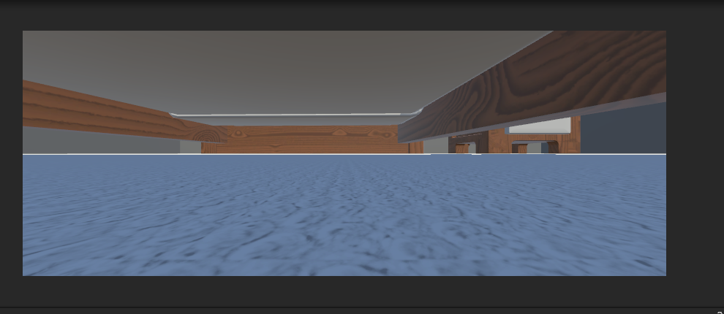

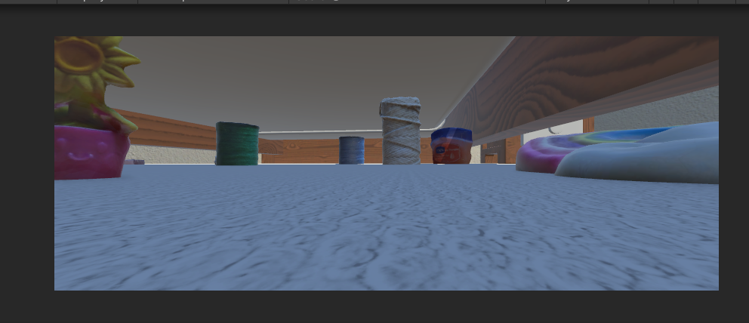

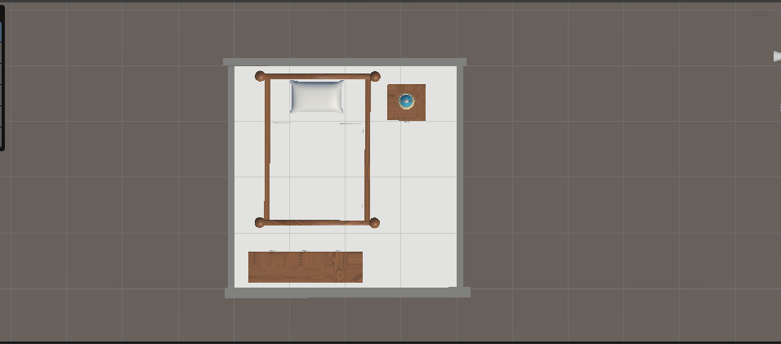

The level represents a tiny room. However, after conducting more research I have decided to only depend on the bed frame since I do not have a similar bed and strictly keep to my own 3D Scans after that.

***Functional and Non-functional Requirements***

**Functional –**

* Moving Enemy AI Monsters, creeping in the darkness and represent insects that usually crawl under our beds at night.
* Character Animation Movements, downloaded through Mixamo.
* Character W, S Movement, done through Visual Scripting.
* Slight Lighting behind the Player Movement Camera to ensure the player can be seen through the darkness.
* Setting up Main Camera alongside Visual Scripting to make sure the Camera follows the player and turns with the mouse movement.
* Terrain collider to collide with the player, player collider to collide with environment, all scans have mesh colliders as well.

**Non-functional –**

* 3D Scanned Objects, aesthetic purposes only, making the realistic atmosphere.
* Bed Model, the whole game aesthetic is hidden underneath this model.
* Carpet material for the “home-like” touch.
* Walls to separate the play-zone from the open world, simple material added.
* Glow sticks underneath the bed as a part of the VFX.
* Capsule Monsters with Glowing VFX eyes.
* Trees, grass, and the whole “outdoor-area” for escaping.

***Assets Reference List***

***

***Harvard Referencing***

JonDevTutorials (2022). *Random AI Patrolling Tutorial Unity3D*. *YouTube*. Available at: https://www.youtube.com/watch?v=dYs0WRzzoRc [Accessed 14 Mar. 2023].

‌